AISC2002 - Data Warehousing and Business Intelligence 01
Module 4 Application Exercise
Group-F
Charitha Priya Dongari – 500191110
Katterapalli Venkata Satya Narayana Reddy – 500190693
Rumana Banu Iliyas Ahmed – 500186725
Rohan Bhatt – 500187633
Shivam Jolly – 500196452

- The below snapshot displays all the Promotions, Periods with extended rows and columns and Average Sales Amount in the cells.
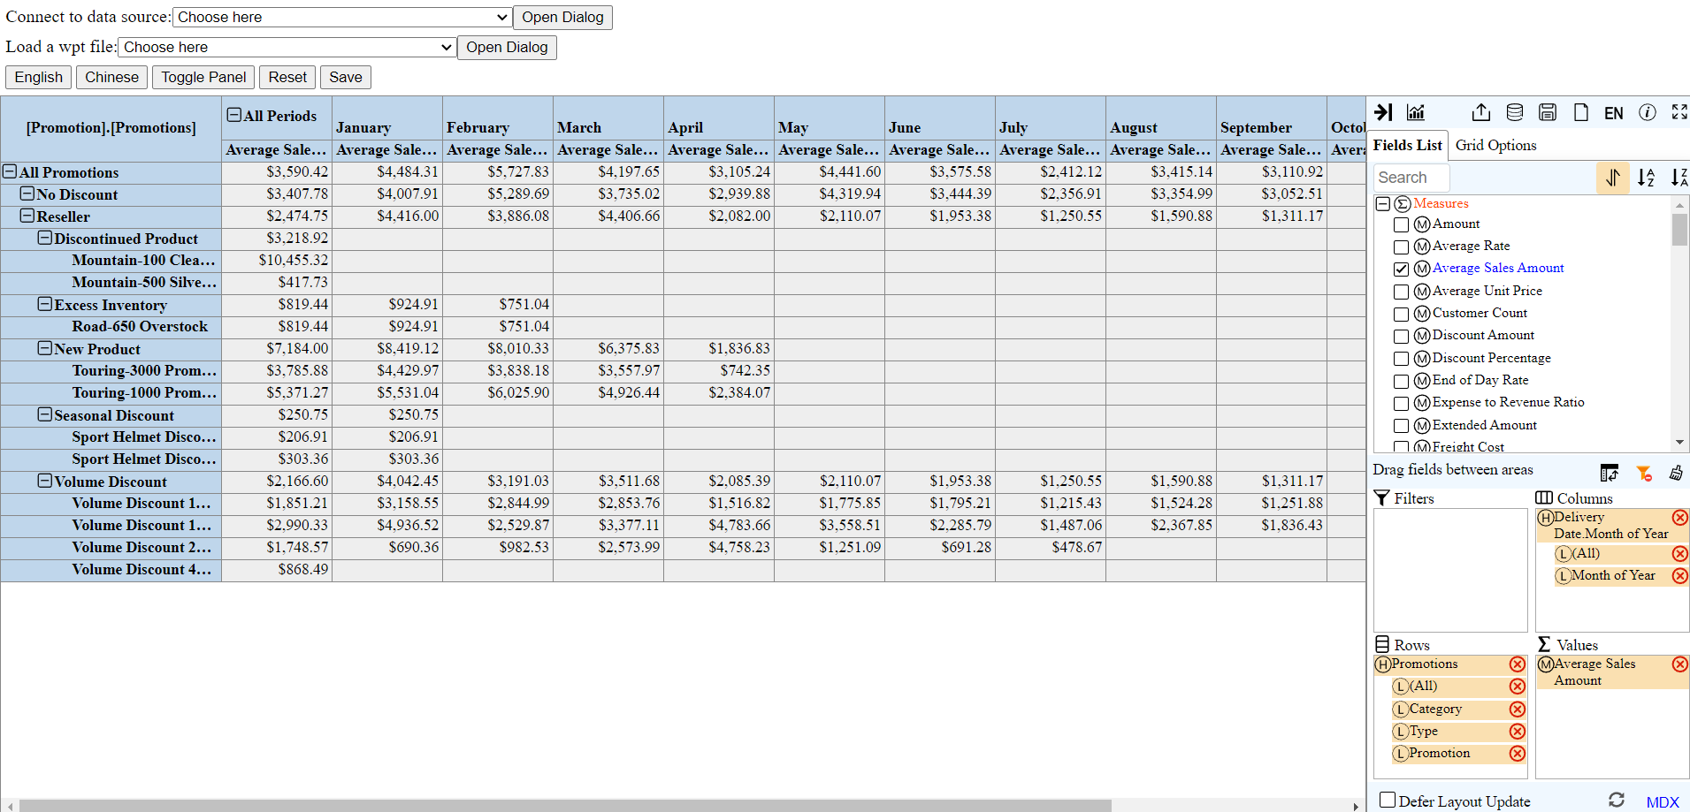

- The below snapshot displays when we set filter in the field settings.
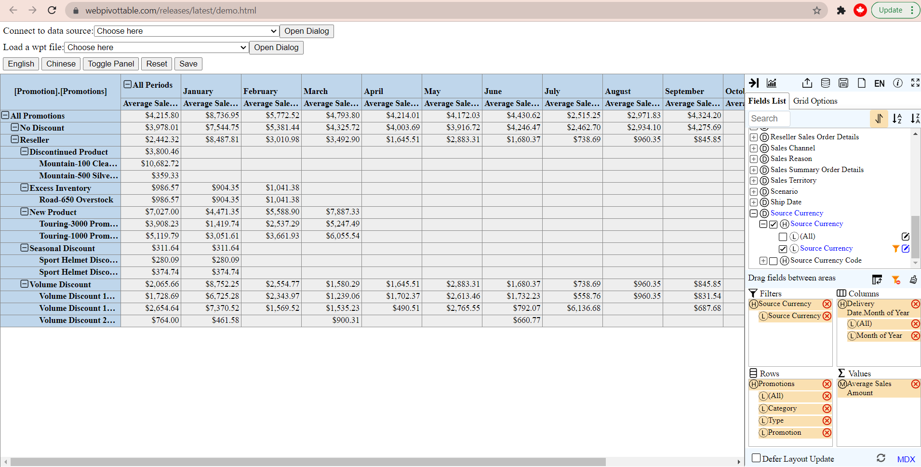
- The below snapshot of All Periods and All Promotions with October Average Sales Amount in the cells.
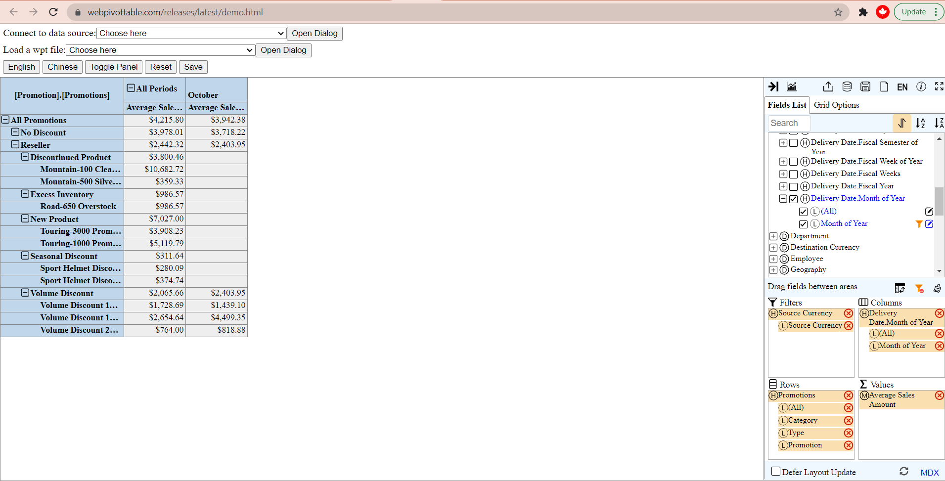
- The below snapshot displays when the source Currency is United Kingdom Pound and when we collapsed all reseller promotions except for “Excess Inventory” and “New Product”.
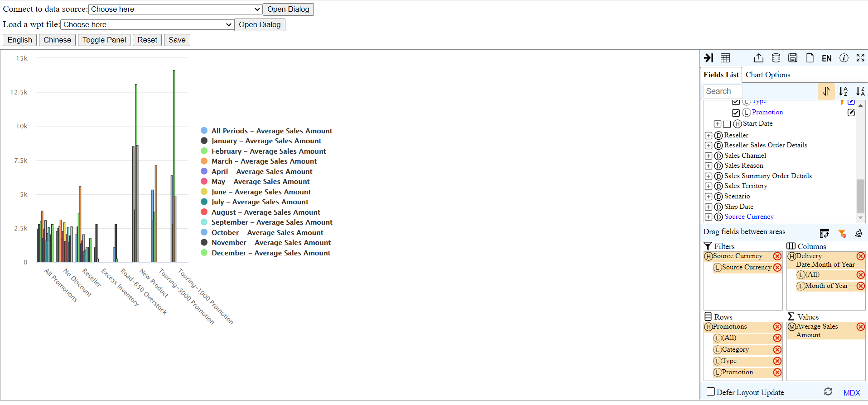
- The below snapshot Displays the same things but for only October month.
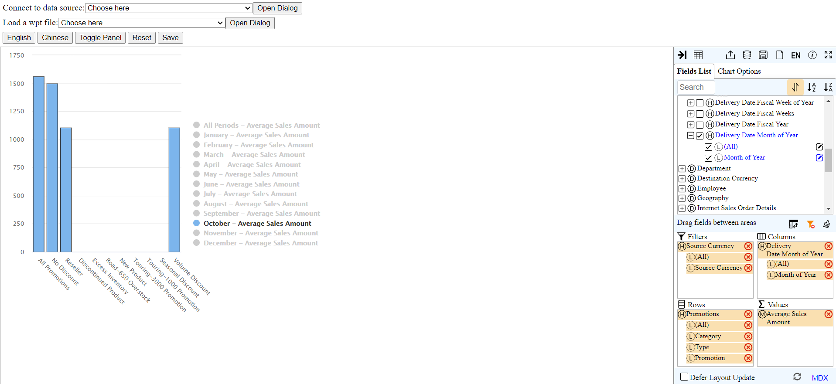
- The below pivot table displays when the source Currency is United Kingdom Pound and when we collapsed all reseller promotions except for “Excess Inventory” and “New Product”.
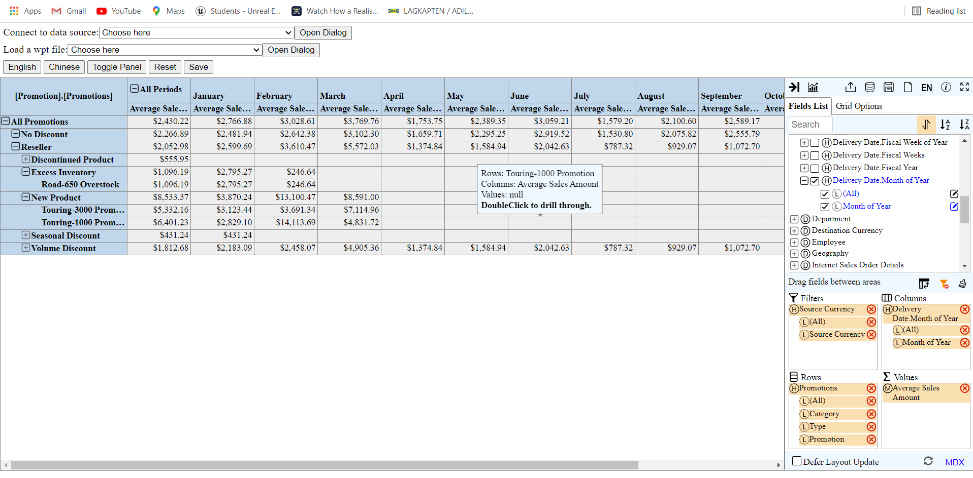

- The below pivot table displays the same thing for the October month.
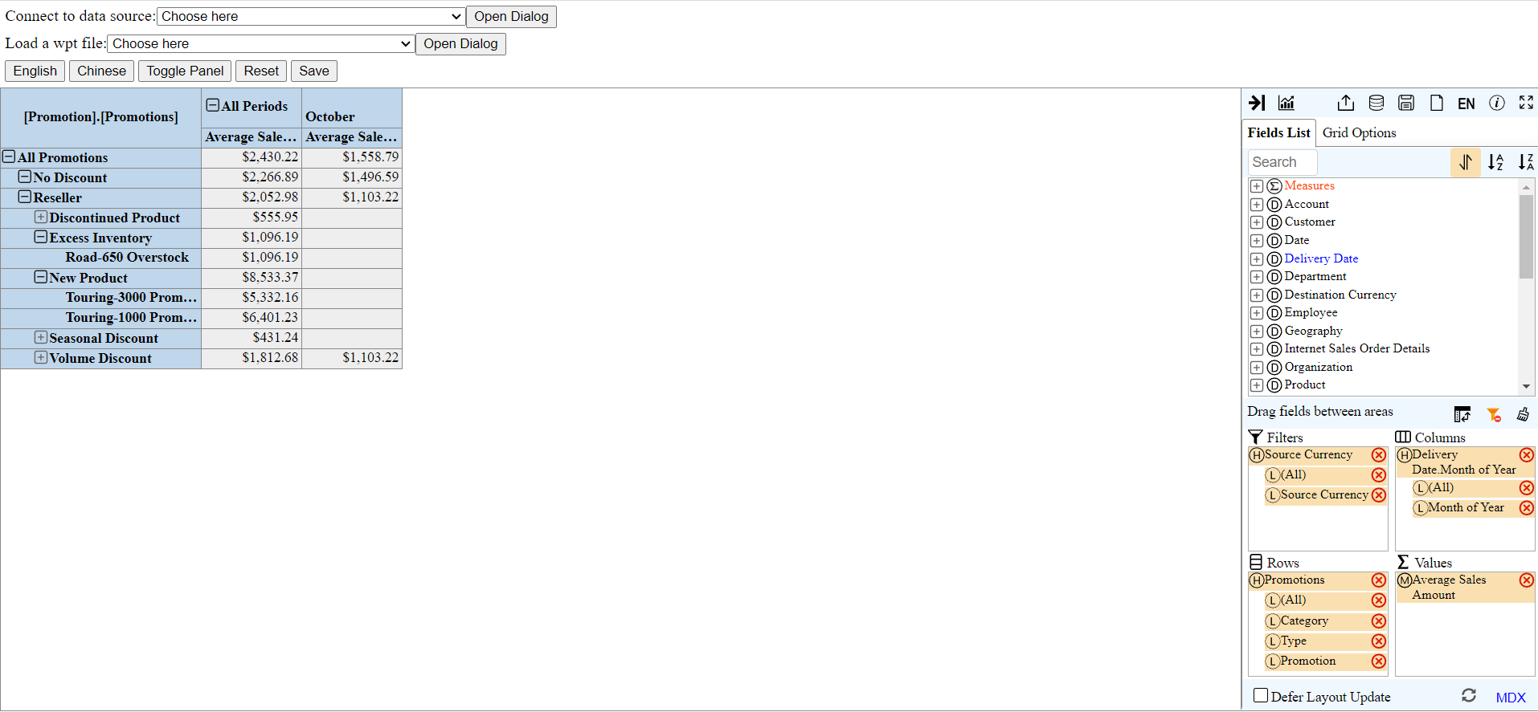
- The below pivot table displays the Average Sales Amount for All Periods along with a subset of the expansion of All Promotions for “Excess Inventory” and “New Product” promotions.
